* 1. **Assignment**

Pick one declaration from the mission or one of the brand values and find marketing examples that help the company convey this.

**Coca-Cola Mission:**

To inspire moments of optimism and happiness...

1st Campaign: Coca Cola - Ramadan 2018 <https://www.youtube.com/watch?v=mqw-ODqbGRo>

2nd Campaign: Coca Cola - Quest - World Cup 2010 Commercial (FullHD) https://www.youtube.com/watch?v=jXtpROFYh0Y

3rd Campaign: Coca Cola 1971 - Hilltop – <https://youtu.be/1VM2eLhvsSM>

4th campaign: Coca Cola Heist <https://youtu.be/bSNCnyCUdk8>

**Brand Values:**

Inspire creativity->

1st Coca-Cola Crates First Ever “Drinkable Advertising Campaign:

<http://www.creativeguerrillamarketing.com/guerrilla-marketing/coca-cola-creates-first-ever-drinkable-advertising-campaign/>

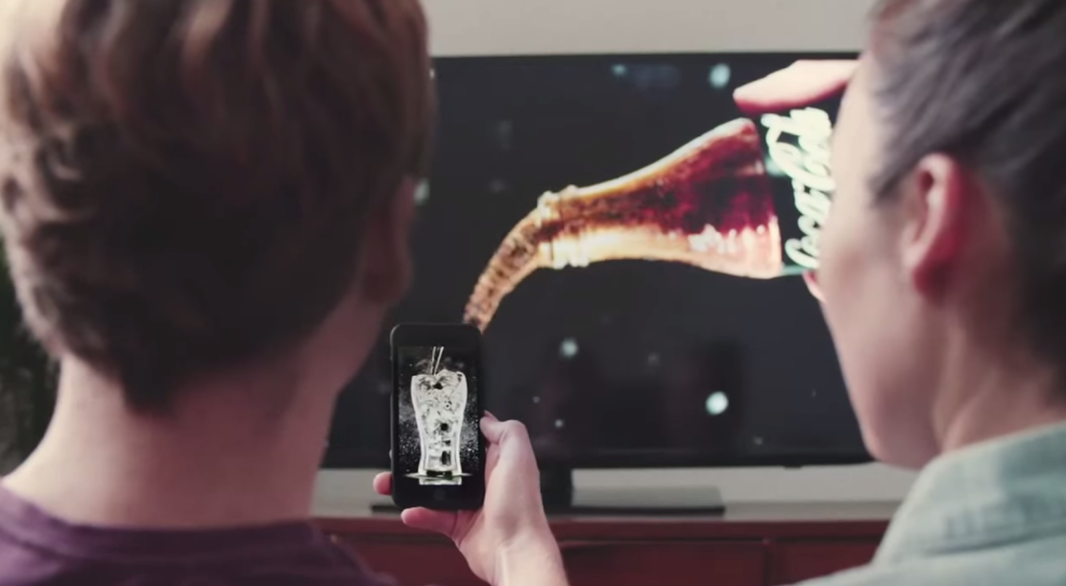

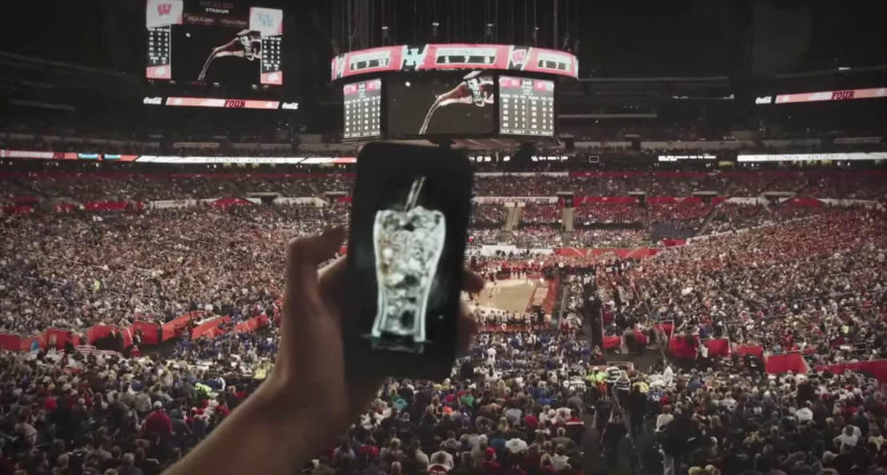

# 2nd Coca-Cola uses red to go green:

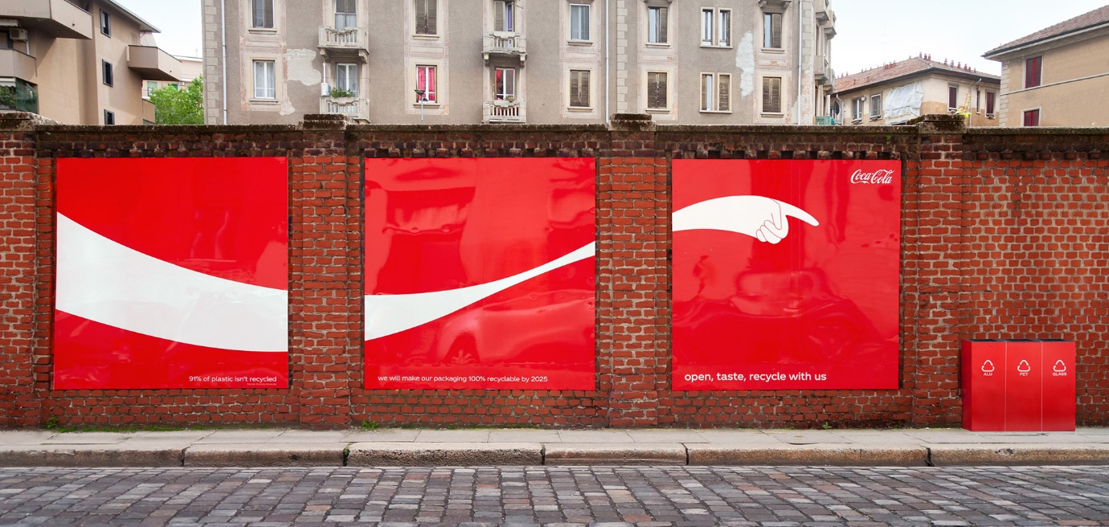

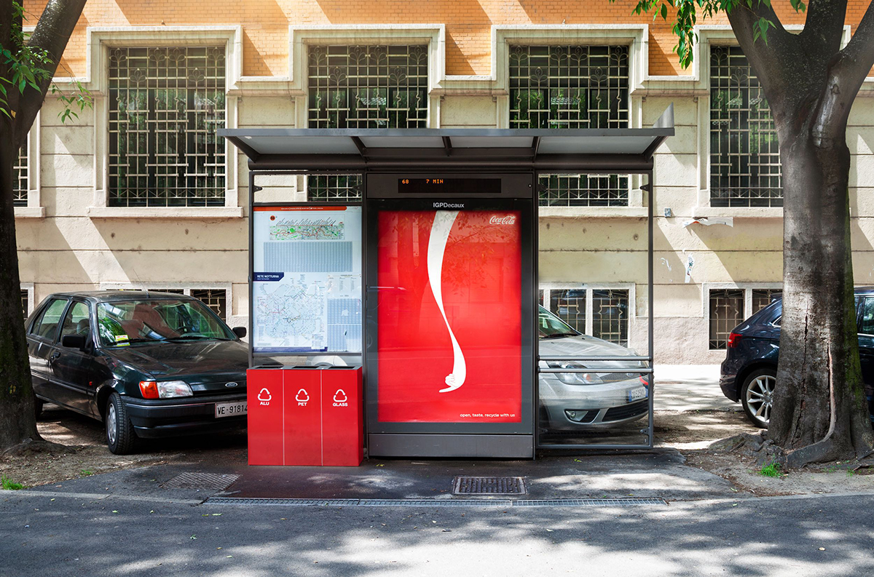

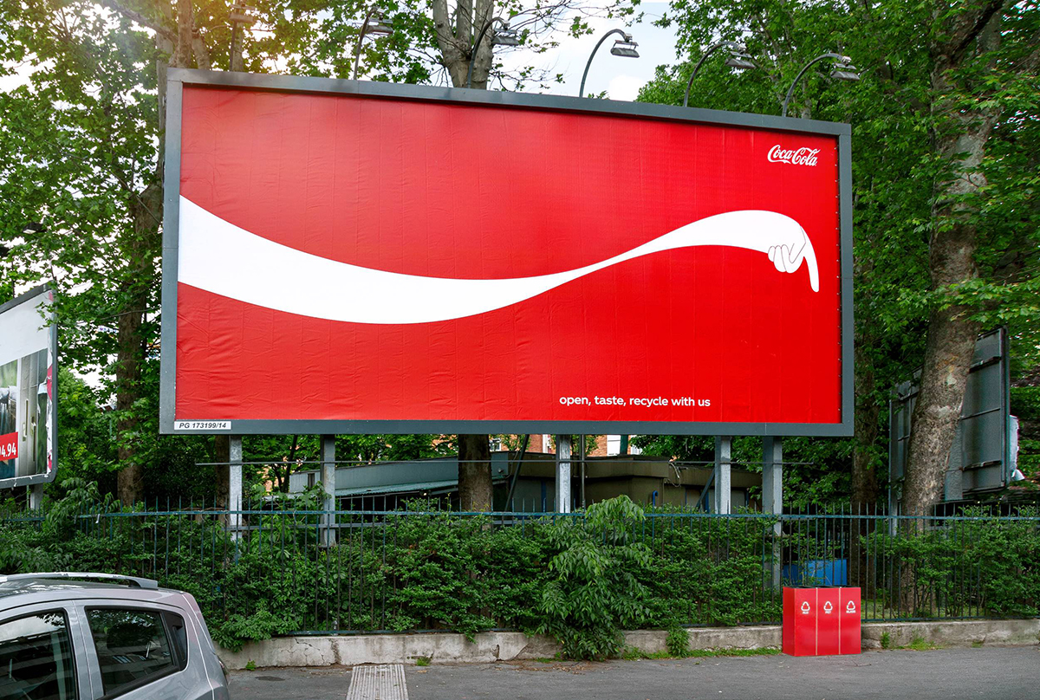

3rd [Coca-Cola](https://www.adsoftheworld.com/taxonomy/brand/cocacola) Friends Campaign:

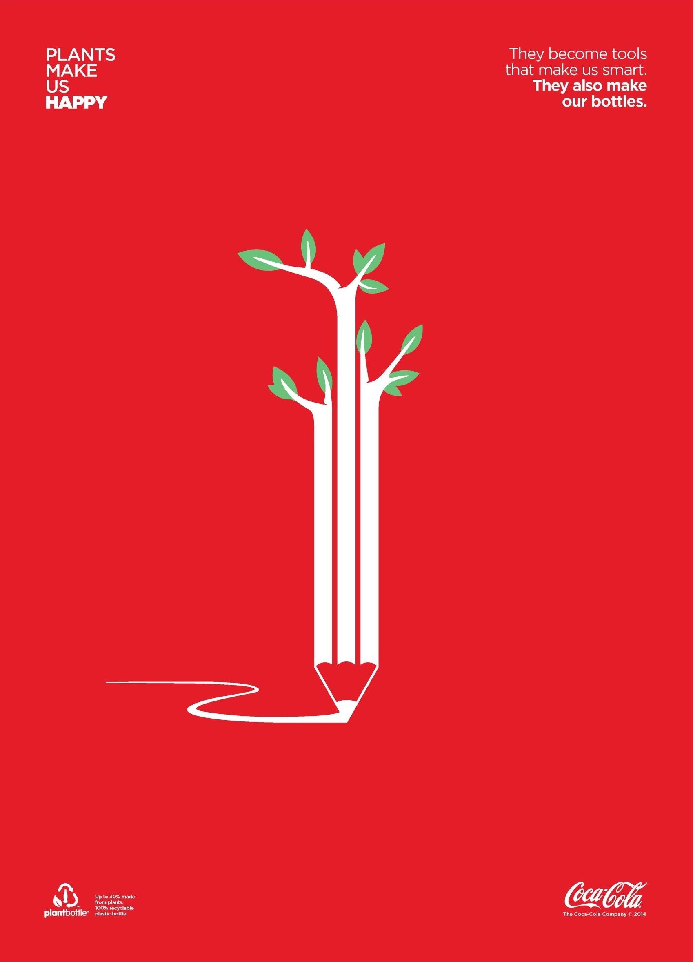

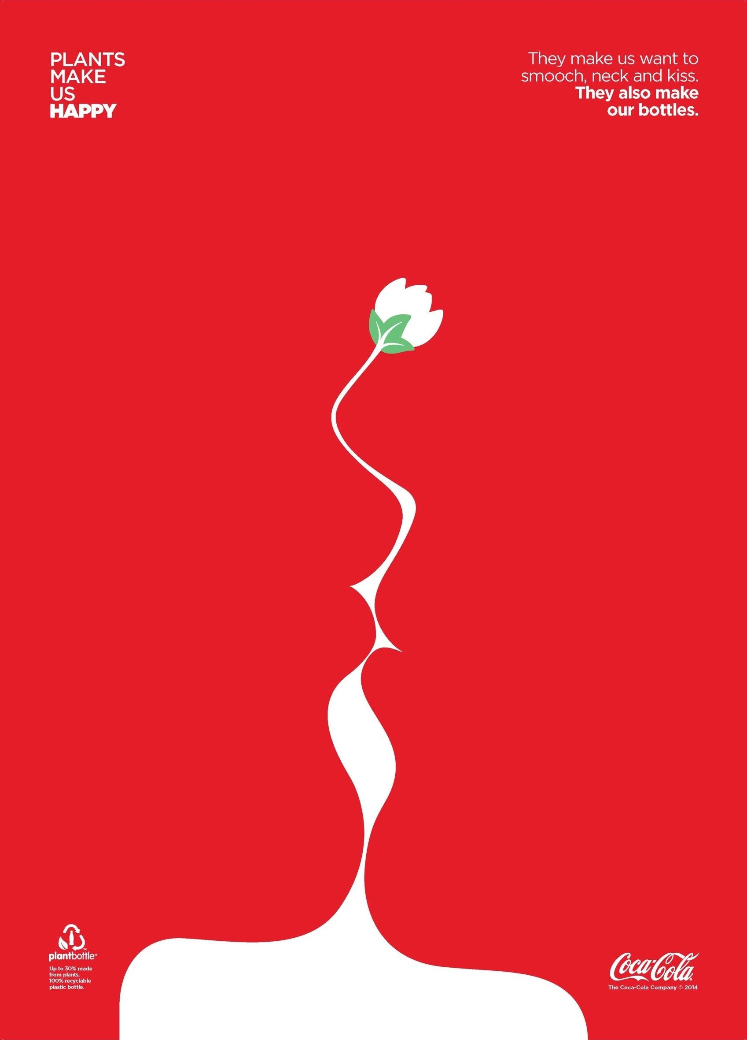

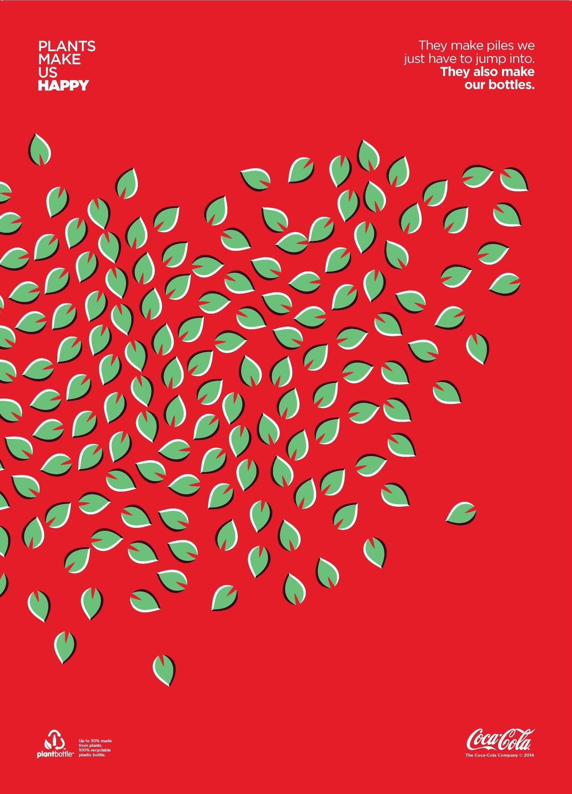

1. **Assignment:**

**Find Examples (Instructions) -> Owned / Paid/ Earned**

**Health and Beauty: Sephora**

**Owned:** Website/Stores/YouTube

<https://www.sephora.com/>

<https://www.youtube.com/user/sephora>

**Paid:** Events

# [Sephora picks 24 influencers for its coveted #SephoraSquad program](https://www.fastcompany.com/90326765/sephora-brings-25-influencers-into-its-coveted-sephorasquad-program) <https://www.fastcompany.com/90326765/sephora-brings-25-influencers-into-its-coveted-sephorasquad-program>

**Earned:** Sephora Community

A lot of reviews from clients in their community

<https://community.sephora.com/>